**Basic Design of Rocket**

Overview

The purpose of the rocket design is to execute a steady flight trajectory with the following objectives:

**Stability Coefficient-** Attain a stability margin (caliber) of at best 2.

**Weight Optimization-** Restrict overall weight of the rocket to a limit of 10 to 12 kg or maybe lower than that.

**Target Apogee-** Attain an altitude of 1000(+/-10) meters.

**Length-** Length should be lesser than 180 cm.

**Motor-** The motor should give maximum 2800 impulse and configuration should be of 98x298mm.

**Feasibility-** The design must be economic, easy to fabricate and safe for use.

The design was developed by using OpenRocket simulation software, where various components such as payloads, avionics, propulsion, and structural parts were integrated to achieve the desired objectives. The design process involved several iterations where certain parameters were changed and adjusted in order to increase stability and reduce the weight while attaining the maximum apogee of 1000 m.

**Design Process**

1. **Initial Design**

The early conceptualization of the design was created before the mission requirement guidelines release date.

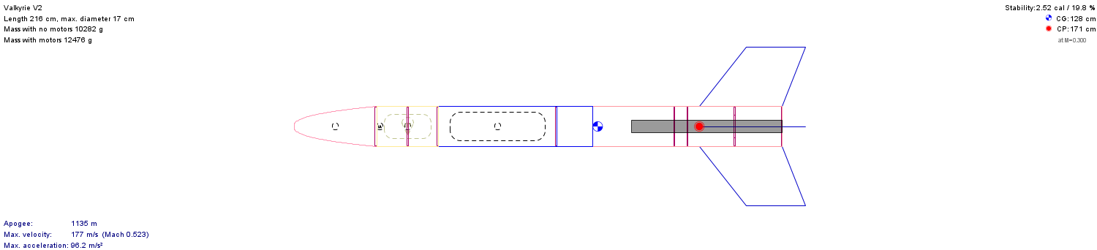

It focused on developing the core structure, including:

1. Airframe- Carbon fiber was used as it is lightweight and high strength to weight ratio.
2. Payload section – Here the cansat was placed along with other payloads such as gyroscope, camera etc.
3. Avionics Bay: This section is built to accommodate the sensors, flight computers, and power supplies.
4. Recovery System: Features a sideways deployment parachute system for effective safety during recovery of the payload.
5. Propulsion System: Comprising a single stage rocket motor capable of producing enough thrust to attain 1000m apogee.

It had the below **results**:

* Stability(caliber)- 2.52
* Weight(grams)- 12476 grams
* Apogee – 1135 m
* Length – 216cm
* Motor used – Aerotech L1000-18

1. **Modifications and Optimizations**

* Stability Improvements-

The size of the fin was increased and the position of the fins was changed so that the center of pressure (CP) was further back the center of gravity (CG), modifying the stability margin to 1.93 considering all the required goals.

The nose cone design was altered from power series with shape parameter 0.5 to power series 0.3 shape in order to improve streamline flow and reduce resistance.

Redesigned the layout of the airframe in order to Shift the CG position without affecting the balance in flight.

* Weight reduction-

Material Selection: Switched from standard aluminum to a lightweight carbon-fiber composite for the airframe and motor casing, reducing the overall structural weight.

Component Streamlining: Reduced the size and weight of the avionics bay by integrating multi-functional sensors and using a compact flight computer.

Motor Sizing: Optimized motor sized according to the motor given in the mission requirements with motor weight upto 300grams. The selected motors that meet the desire requirements are Aerotech k650-P and Aerotech k680-P.

* Apogee

After adjusting the propulsion system parameters (thrust, specific impulse), a more efficient motor was selected to increase the apogee.

Reduced overall drag coefficient by refining the aerodynamic profile of the rocket (using simulations) to achieve less drag during flight.

Implemented payload optimization by reducing non-essential equipment to lighten the load.

**Final Results**

1. Stability margin- 1.93(caliber)
2. Total weight – 11947grams
3. Apogee – 1000m (exactly)
4. Length – 164 cm
5. Motors – Aerotech k650-P or Aerotech k680-P with 2380 impulse(avg).

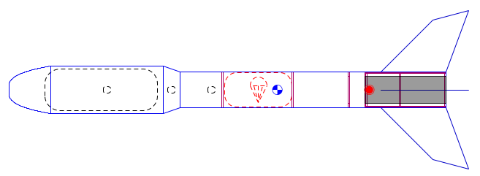

1. **Simulation and Testing**
2. Stability Testing:

Several simulations were conducted to confirm that the rocket follows a stable flight path even under wind disturbances and the final design flies with sufficient stability during the flight with minor trajectory variations.

1. Apogee Analysis:

The rocket is able to achieve an altitude of 1000-1010 meters in every environmental simulation carried out (temperature, wind speed) and this was recorded in the OpenRocket simulation data and verified through calculations by hand.

1. Recovery System Testing:

The recovery system testing focused on the sideways deployment of parachute system, modeled for efficiency and a safe descent between 2 to 5 m/s for the airframe and payload.